TUGAS BAB I

Berkut dalah programnya

import 'dart:async';

class User {

String name;

int age;

late List<Product> products;

Role? role;

User(this.name, this.age) {

products = [];

}

}

enum Role { Admin, Customer }

class Product {

String productName;

double price;

bool inStock;

Product(this.productName, this.price, this.inStock);

}

class AdminUser extends User {

AdminUser(String name, int age) : super(name, age) {

role = Role.Admin;

}

void addProduct(Product product) {

if (product.inStock) {

products.add(product);

print('Produk "${product.productName}" berhasil ditambahkan.');

} else {

print('Gagal menambahkan produk "${product.productName}". Produk tidak tersedia.');

}

}

void removeProduct(String productName) {

try {

Product? productToRemove = products.firstWhere((product) => product.productName == productName);

products.remove(productToRemove);

print('Produk "${productToRemove.productName}" berhasil dihapus.');

} catch (e) {

print('Kesalahan: Produk "$productName" tidak ditemukan dalam daftar.');

}

}

}

class CustomerUser extends User {

CustomerUser(String name, int age) : super(name, age) {

role = Role.Customer;

}

void viewProducts() {

if (products.isEmpty) {

print('Tidak ada produk yang tersedia.');

} else {

print('Daftar Produk:');

for (var product in products) {

print('- ${product.productName} (${product.inStock ? "Tersedia" : "Tidak Tersedia"}): \$${product.price}');

}

}

}

}

Future<Product> fetchProductDetails(String productName) async {

await Future.delayed(Duration(seconds: 2));

return Product(productName, 150.0, true);

}

void main() async {

AdminUser admin = AdminUser('Alice', 30);

CustomerUser customer = CustomerUser('Bob', 25);

try {

Product newProduct = await fetchProductDetails('Baju Muslim');

admin.addProduct(newProduct);

customer.products = admin.products;

customer.viewProducts();

admin.removeProduct('Baju Muslim');

customer.viewProducts();

} catch (e) {

print('Kesalahan saat mengambil detail produk: ${e.toString()}');

}

}

Berikut adalah hasil running programnya

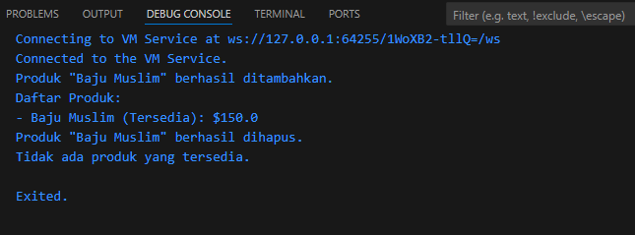

Berikut referensnya

<https://www.tutorialspoint.com/dart_programming/dart_programming_object.htm>

<https://dart-tutorial.com/object-oriented-programming/enum-in-dart/>

<https://dart.dev/guides/language/language-tour#object-oriented-programming>

<https://dart.dev/null-safety#understanding-null-safety>

<https://dart.dev/tutorials/language/async-await>

<https://flutter.dev/docs/cookbook/networking/fetch-data>